

**Actividad #: Titulo**

## Implementación de métodos computacionales

Ernesto Adrián Alvarez Salazar - A00227490

José Rodrigo Saucedo Cruz - A00571371

Germán Andrés Jaramillo - A00571636

17 de febrero de 2021

1. In the tree of Fig. 1.4,
   1. Which vertices are leafs and which are interior vertices?
   2. Which vertices are the sons of 5?
   3. Which vertex is the father of 5?
   4. What is the length of the path from 1 to 9?
   5. Which vertex is te root?

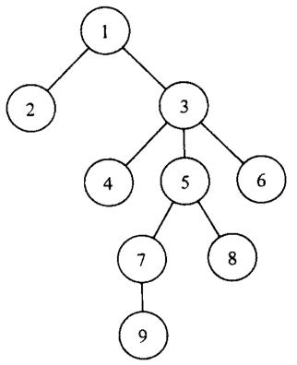

**Fig1.4 A tree.**

1. Prove by induction on that: